OFFICIAL COORDINATION REQUEST FOR
NON-ROUTINE OPERATIONS AND MAINTENANCE

COORDINATION TITLE - 14 IHR 009 Ice Harbor Dam Study 6.2.1. UPDATE.

COORDINATION DATE- 04 September 2014

PROJECT- Ice Harbor Dam

RESPONSE DATE- September 11, 2014 FPOM meeting

Description of the problem: UPDATE. Study dates in Appendix A were for February to August 2014 with coordination of Ice Harbor and FPOM.
Study has been delayed.
Installation of the steel pipes will coincide with IHR unit 3 stator repair ongoing this month. Study testing is now scheduled for October 6 to the 22, 2014.

A research study is being planned for implementation at Ice Harbor Dam involving the release of sensors into turbine unit 3 during September and October, 2014. This study will require steel pipes to be mounted directly to the cross members of the STS in the B slot of unit 3. This installation will require Project support to lift and reinstall the STS once pipes are attached. The installation is tentatively being considered for the week of 8 September as turbine unit 3 is currently undergoing stator repair. Equipment removal is not required prior to pulling screens in December.

Testing turbine unit 3 at generator limit (approximately 14.1kcfs) is planned. It is expected that no more than 5 days of operation at this high discharge will be required. Unit 3 is the second priority unit and adult salmonid attraction to the south fishway is important during the late summer and fall months. If river flows are low enough to operate only one turbine unit it will be necessary to have Regional consensus on operating unit 3 rather than unit 1 during testing.

Sensors will be recaptured in the tailrace, which will require boat access to the BRZ.

Type of outage required: If sensor release pipes are installed during the unit 3 outage and removed in December when screens are pulled there will be no further unplanned outage required for equipment installation or removal. Unit 3 is currently scheduled for outage 4 – 29 August with extended outage to approximately October 3 for stator repair.

If river flow is too low to operate two units during the testing of unit 3, unit 1 will need to be off line during testing.

Impact on facility operation: The required Project support for installation of sensor release pipes has been coordinated through District Operations and with the Ice Harbor Project. We still have flexibility in our schedule to cooperate with Project schedules.

During the study it will be necessary for the Project Control Room Operator and PNNL crews to communicate well. There will be four prescribed turbine unit operations; three within the 1% range and generator limit. The Operator will need to ensure that the turbine unit is operating appropriately according to the schedule. The Operator will also need to be in contact with the boat crew in the tailrace during BRZ access.

Operating turbine unit 3 at generator limit in November may be difficult depending upon river conditions, and the unit may also be de-rated once the unit comes back online after stator repair. Mean river flow typically exceeds approximately 18kcfs, but in a low flow year flows may drop near 15kcfs (Figure 1). Should low flow be problematic, the Operator will need to communicate this with the research crew so that testing may be adjusted as appropriate.
Originally, it was proposed that testing would only occur in October to ensure more friendly weather and longer day length compared to November; however, at the request of FPOM on 11 September, 2014, we have adjusted the schedule to collect data at the generator limit during the first week of November to avoid conflict with the 1% hard constraint presented in the Fish Passage Plan. Below is the new testing schedule.

Proposed Schedule:
  - Installation of Release Pipes: Sept 8 - 11, 2014
  - Test – Lower 1%: Oct 6 - 9, 2014
  - Test – Peak Oct 10 -14, 2014
  - Test –BOP/design limit for fish passage: Oct 15 - 17, 2014
  - Test – Upper 1%/generator limit: Nov 3 - 6, 2014
  - Removal of Release Pipes: after Dec 16, 2014

Specific megawatts for each operation will be provided to the Operator prior to beginning data collection.

Length of time for repairs: NA

Expected impacts on fish passage:

Juvenile Passage: There are expected to be no impacts to juvenile passage and survival during release pipe installation or testing. Unit 3 will be out of service when the STS is pulled for release pipe installation. There are very few fall Chinook (Figure 2A) or steelhead smolts (Figure 2B) outmigrating during the proposed timeframe. It is estimated that ≤ 2.53% of the total juvenile fall Chinook and ≤ 0.03% of juvenile steelhead runs will pass Ice Harbor during the September – October study period based on ten year average smolt monitoring data from Lower Monumental Dam (DART 2014). If a single operating turbine unit is the only passage route and is operated at generator limit for a total of 7 days, 0.29% of the fall Chinook run may pass in that week. Assuming a low estimate of approximately 77% (Moursund et al. 2004) fish guidance efficiency, only 0.07% of the fall Chinook run would pass through the turbine unit when operating at generator limit during that week. Turbine survival estimates have ranged from 88% (Absolon et al. 2005) to 96% (Normandeau 2008) for radio telemetry and balloon tag studies, respectively; therefore, it is reasonable to assume no measurable impact to juvenile salmonid passage and survival.

Adult Passage: There are no expected impacts on adult salmonid attraction or passage at the south fishway resulting from operating unit 3 singly rather than unit 1, should that be necessary. A statistical analysis of adult steelhead passage at the Ice Harbor south fishway relative to turbine unit operations between 2005 and 2013 was completed in 2014. The results of this analysis indicated that no significant difference in passage occurred when unit 3 was operated compared to unit 1 (Figure 3A-B and Figure 4; Trumbo et al. 2014).

Comments from agencies
Sept. FPOM meeting Sept 11, 2014:
Operating at generator limit during October is unacceptable. Recommended that testing dates are moved to November to eliminate conflict with the 1% hard constrain through October.

Final results:

Thank you,

Brad Trumbo
Fishery Biologist
Walla Walla District
bradly.a.trumbo@usace.army.mil
509-527-7253

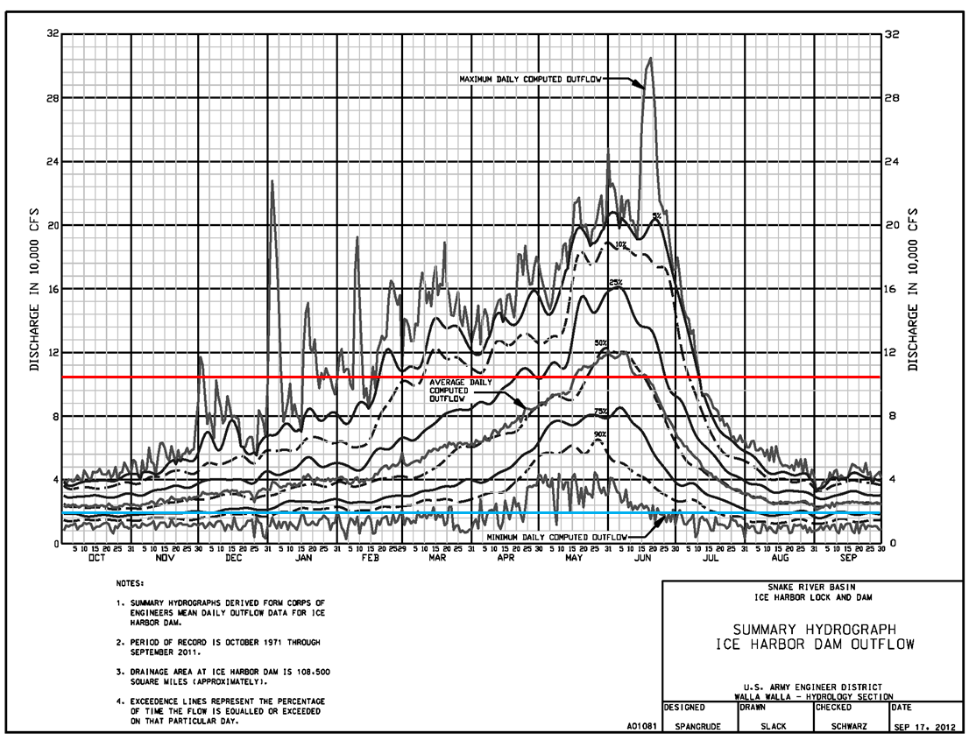

Figure 1. Ice Harbor Dam forty year mean daily discharge with exceedence curves for the period of October 1971-September 2011. Discharge is presented in 8 kcfs increments. The red line represents the powerhouse hydraulic capacity at approximately 106 kcfs and the blue line represent extremely low flow at approximately 18 kcfs.

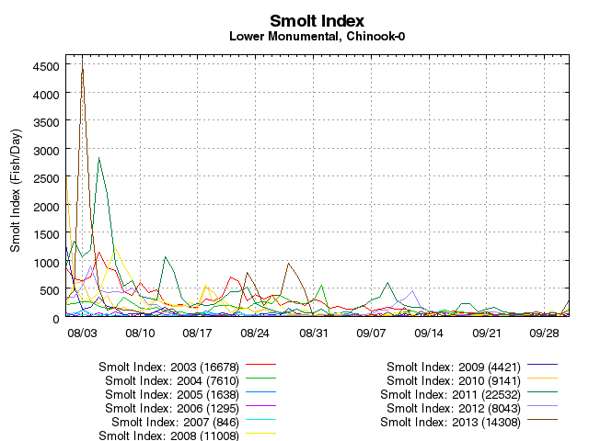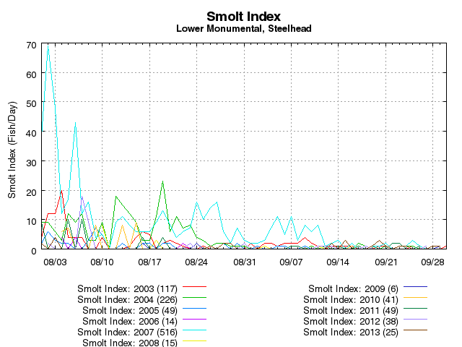
B
A

Figure 2. Smolt passage index for subyearling fall Chinook (A) and juvenile steelhead (B) at Lower Monumental Dam, 2003 – 2013. This data suggests that ≤ 2.53% of the total juvenile fall Chinook and ≤ 0.03% of juvenile steelhead runs will pass Ice Harbor during the September – October study period.

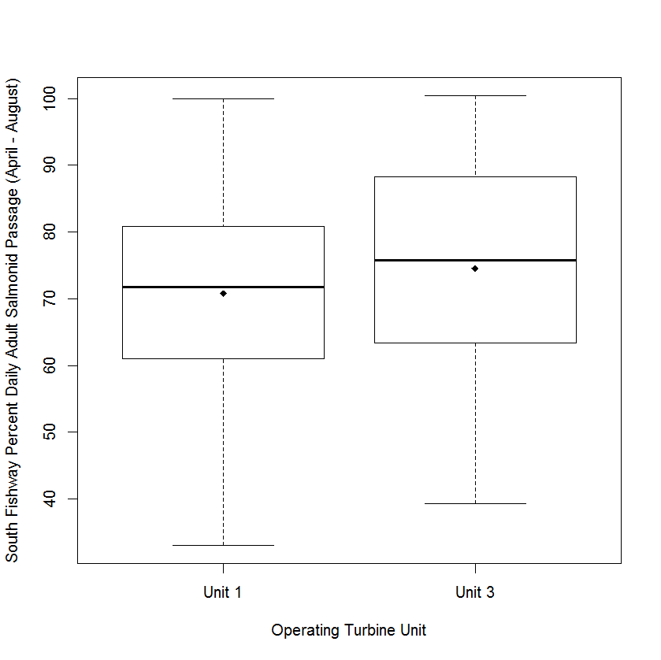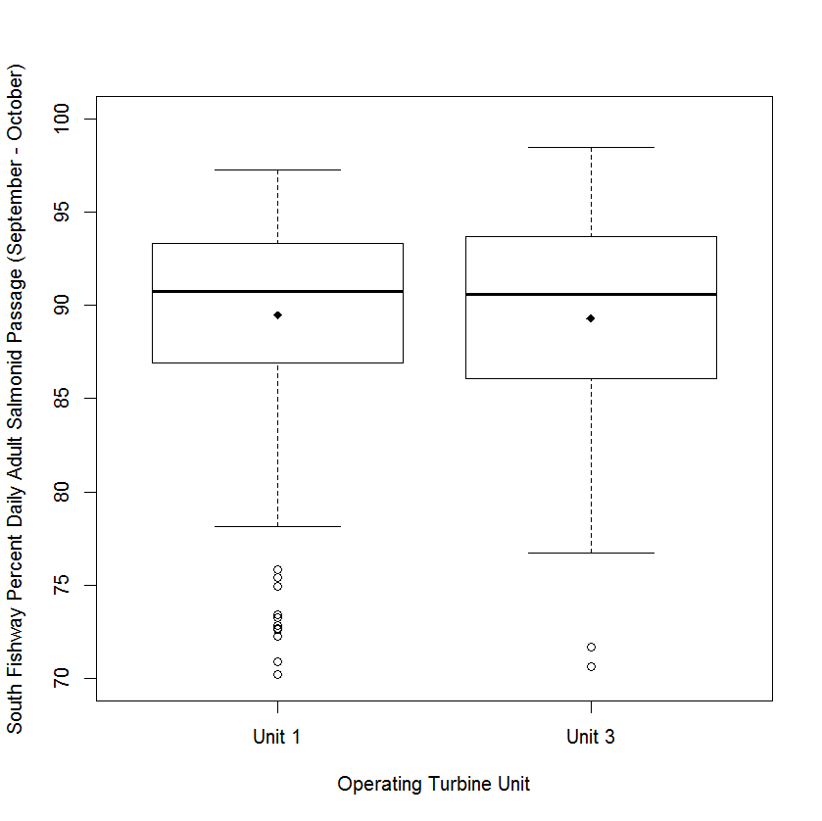
B
A

Figure 3. Ice Harbor south fishway adult salmonid passage percentage, 2005 – 2013, relative to priority operating turbine unit. Panel A provides the range of daily passage parentages for the April – August fish passage season with spill and panel B provides the range of daily passage parentages for the September - October period with no spill. Model estimated difference in mean passage percentage between operating turbine unit was approximately 3% for both timeframes. Boxes represent 25th and 75th percentiles with the solid black line representing the median (50th percentile) and the diamond represents the mean. Whiskers represent 10th and 90th percentiles and dots represent 5th and 95th percentile outliers. Unit 1 had a shorter median passage time, but the means are nearly the same.

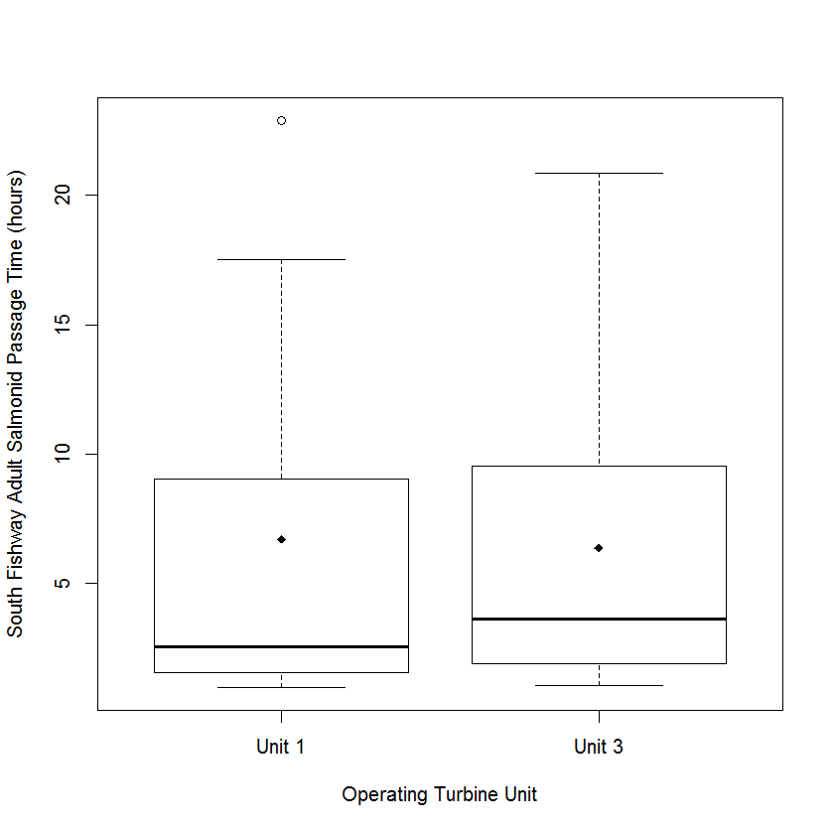

Figure 4. Ice Harbor Dam south fishway adult salmonid passage time for 2004, 2009 and 2013 combined. First detection was just downstream of the tailrace entrance and last detection was within the south fishway entrance. Boxes represent 25th and 75th percentiles with the solid black line representing the median (50th percentile) and the diamond represents the mean. Whiskers represent 10th and 90th percentiles and dots represent 5th and 95th percentile outliers. Unit 1 had a shorter median passage time, but the means are nearly the same and no statistically or biologically significant difference was found in passage times between the single priority operating unit.

References:

Absolon RF, BP Sandford, BM Eppard, DA Brege, KW McIntyre, EE Hockersmith, and GM Matthews.
2005. Relative Survival Estimates for PIT-tagged Juvenile Chinook Salmon Passing Through
Turbines, Collection Channels, and Spillways at Ice Harbor Dam, 2003. Report of the National Marine Fisheries Service, Seattle, Washington, for the U.S. Army Corps of Engineers, Walla Walla District, Walla Walla, Washington.

Columbia River DART. 2014. Columbia Basin Research, University of Washington. Available from http://www.cbr.washington.edu/dart

Moursund RA, KD Ham, PS Titzler, and F Khan. 2004. Hydroacoustic Evaluation of the Effects of Spill
Treatments on Fish Passage at Ice Harbor Dam in 2003. PNWD-3420, Report of Battelle-Pacific
Northwest Division, Richland, Washington, for the U.S. Army Corps of Engineers Walla Walla
District, Walla Walla, Washington.

Normandeau Associates, Inc. 2008. Turbine operational effects on survival/condition of yearling Chinook salmon, Oncorhynchus tshawytscha, at Ice Harbor Dam, March 2007. Report Prepared for the US Army Corps of Engineers, Walla Walla District, Walla Walla, Washington.

Trumbo, BA, MK Shutters, JF Renholds, ML Ahmann, and KE Crum. 2014. Ice Harbor test turbine fixed blade runner installation considerations for adult salmonid passage. Report of the US Army Corps of Engineers, Walla Walla District, Walla Walla, Washington.

